 **TIJUANA INSTITUTE OF TECHNOLOGY**

**ACADEMIC**

**DEPARTMENT OF SYSTEMS AND COMPUTATION COMPUTER**

**SYSTEMS ENGINEERING**

**SEMESTER**

FEBRUARY- JULY 2022

**SUBJECT**

BDD-1703SC9C Data Mining

**Activity**

Practice 4

**Teacher**

MC JOSE CHRISTIAN ROMERO HERNANDEZ

**Student**

17212327 -Aldarete Delgado Angel Esteban

17210659 - Villegas Carmona Damaris

Instructions

Analyze the code corresponding to the data visualization of the machine learning model K Nearest Neighbors K-NN.

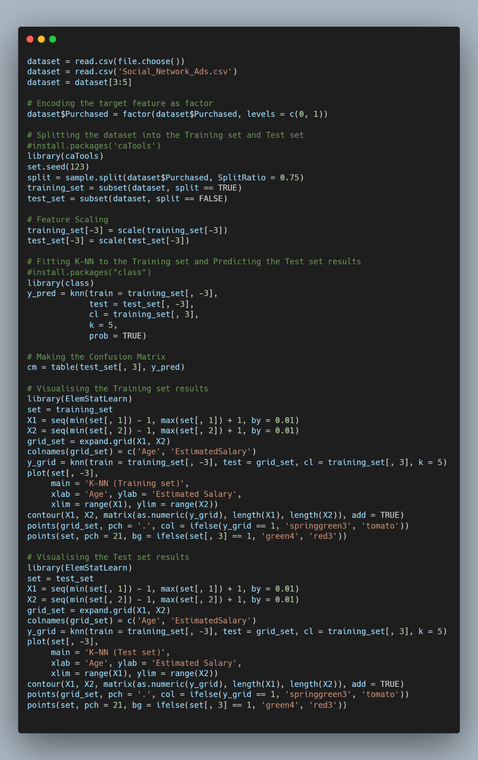

In the first image you can see the result of the analysis corresponding to the training set.

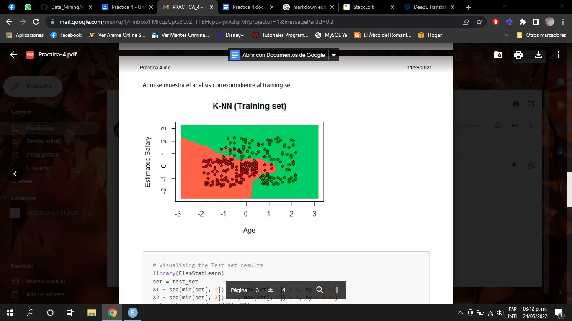

The second image shows the analysis corresponding to the test set.

